  
  
  
  
UNIVERSITY OF CONNECTICUT SCHOOL OF BUSINESS  
COURSE OPIM 5272 – FALL 2015 – CLASS PROJECT

**THE TRAVEL APPROVAL & REIMBURSEMENT PROCESS**

**PROJECT PHASE I – PROCESS MODELING**  
PROJECT PHASE II – DATABASE DESIGN  
PROJECT PHASE III – DATABASE IMPLEMENTATION

**WRITTEN BY TEAM FOUR**  
RIttha ARAYARUNGSARIT, DIE CHEN, ZHONG HE,   
PRADEEP JEYACHANDRAN, JULIAN VROHLINGS

**The business – Stark Sealing Solutions**

Our team has studied a simple business process in a medium-sized German company that has grown exceptionally in size within the last five years. Stark Sealing Solutions (real name replaced) offers all kinds of sealing solutions to other businesses. For example, solutions are offered to seal pipes, undersea fibre cables, windows, fuel tanks, tunnels and large machines. Due to the individual requirements and technical specifications, most employees work in small project teams together with the client. In a combined effort, they develop, create and test materials that are safe and durable for the product they shall be used for. As this usually takes place at the client site, it is important that employees are willing and able to travel within all of Europe. The company has 5,000 employees at three sites in Germany, France and Sweden, 3,000 of which need to travel for this reason on a regular basis.

Recently, there has been a growing number of complaints by both employees and managers, regarding the business rules and processes that have been set up around the topic of traveling. They say, it takes too much time to obtain approval for a trip to the customer, and also, it takes up to a month to get the money back (as most other companies, Stark asks its employees to advance the money spent on business travel and reimburse them later, as it speeds up booking/cancelation process). Additionally, when repeating the trip multiple weeks in a row, the process has to be run through every single time. A few years ago, when the company was much smaller, and most of its clients where located in the same region, the existing process may have been efficient, but as this has changed and traveling is very costly, and working time is a valuable resource, this is a process that needs to be examined.

**The current process – sequential and paper-based**

For compliance reasons, there are five different people involved all the way from identifying the need to travel (triggering event) and the reimbursement being completed. These people are:

* The employee requesting and booking a trip, traveling, collecting the receipts, creating the expense report, and finally confirming payment (responsible for achieving business success in projects)
* The employees first line manager, who has to perform a check if the employee is eligible to travel and if the expenditure matches the amount requested and the companies guidelines (responsible to ensure business success on all projects of his department)
* The CFOs secretary, who performs a formal check before giving it to her manager
* The CFO, who is the only one to make/sign decisions on spending
* The finance department, which can trigger the reimbursement to the employee

As the company handles and archives travel requests and reimbursement separately at each location, it has become common practice to print out and hand over everything to the next person. This is the reason why the process has to be sequential. Most of the time, the employee, and sometimes his manager identifies the need to travel to the client location (triggering event). After this, the process starts:

* The employee fills out a travel request form. He has to provide is name, workplace location, employee ID, department, the project and client ID, the estimated travel time and dates, estimated hotel, transportation and other costs, as well as a short description of the purpose of the travel.
  + He places the request on his managers desk or gives it to him in person
* The manager reads the form
  + No approval: he writes remarks on the request, instructing him how to adjust the request
  + Approval: he signs the request and places it on the CFOs secretaries desk
* The secretary double-checks if information is missing
  + Insufficient information: remarks on the request, including instructions on how to proceed
  + Sufficient information: collects forms from different employees and hands them over to the CFO for approval once a day
* The CFO reads through the request
  + No approval: he writes remarks on the request, including instructions for the secretary
  + Approval: he signs the request, handing it back to the secretary
* The secretary places the signed request form on the desk of the employee
* The employee proceeds with the booking. He is instructed to book only hotels, airlines, train services and rental car companies that are in from a “Partners of Stark“ list, if possible.
* The employee collects all receipts and bills while traveling
* After traveling, the employee creates the expense report. This includes an overview of the cost, using an excel form, printing it out and stapling all receipts to it
  + He places the report on his managers desk together with the initial request
* The manager reads the report and compares it the initial request
  + No approval: he writes remarks on the report, instructing him how to adjust it
  + Approval: he signs the report and places it on the CFOs secretaries desk
* The secretary double-checks if information is missing
  + Insufficient information: remarks on the report, including instructions on how to proceed
  + Sufficient information: collects reports/initial request from different employees and hands them over to the CFO for approval once a day
* The CFO reads through the report
  + No approval: he writes remarks on the report, including instructions for the secretary
  + Approval: he signs the report, handing it back to the secretary
* The secretary archives the report
* The secretary instructs the finance department (email including the amount to reimburse, the employee and project ID)
* The finance department transfers the money to the employees account
  + The finance department asks the employee for confirmation the money has arrived
* The employee confirms that he has received the money
* The reimbursement process is completed

This is a business process because it includes interrelated tasks (no task is independent from all other tasks), all tasks work towards a specific goal/result (reimburse employees), and it has a triggering event (in this case an action event). Compared to other business processes, this process is relatively easy, as all tasks are handled sequentially and the steps performed do not require deep understanding of finance. Nevertheless, as pointed out earlier, it is very important that business processes like these do not prevent employees from working efficiently on the main tasks they by taking away their time. Indirectly, the customer will benefit from improving this process. Starks project members should be less overwhelmed by the amount of administrative work to be done, and rather focus on the work to be done with the client. The direct „customers“ (or stakeholders) of this process are all internal: all parties involved in the as-is process described above would benefit from a streamlined travel and reimbursement process.

**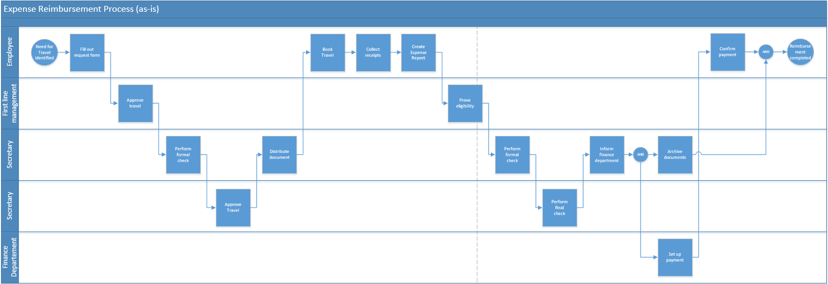***The current process – sequential and paper-based (to keep it simple, iterations have been removed)*

**Problems with the current process**

As already pointed out, the overall process uses too much of the employees and managers time. This leads to very high risk and quite a few other inefficiencies:

* Managers can be sick/traveling/on vacation, the delay can prevent the employee from traveling (request has not been signed on time, hotels/rental cars/flights/trains are sold out in the meanwhile). This influences customer satisfaction directly in a very negative way.
* Most employees have enough money to advance a payment for a single trip. But if it takes up to a month to get the money back, this might be a major concern to them, prevent them from traveling or even make them wanting to leave the company if no action is taken.
* If there was no delay at handover, the booking part of the process could be finished in less than twenty minutes, the reimbursement process in less than half an hour. However, it is estimated that requests and reports are waiting for approval more than 95% of the time during the whole process (for example because the CFO only handles requests/expense reports once a day)
* Because it is paper-based, it is difficult to get a history of an employees trips, discover potential fraudulent activities, get a status of an open request/report or reduce the risk of error when comparing the request to the final expense report
* Because the process doesn’t work anymore, employees invent workarounds that sometimes are not compliant with business rules & legislation
* Project managers struggle to locate and assign travel-related costs to their projects, they must go to the archive or ask the people who traveled regularly

It is important to change the status quo, and enable Stark Sealing Solution to spend time on what creates revenue and customer satisfaction. This is not only true in the short term, but also in the long term, as the company continues to grow in size.

**Improving the process**

We have identified different areas in which the process can be changed in order to be more efficient:

* Workflow Redesign
  + Let the CFO delegate the travel request approval completely to the first line manager. This requires trust, but after all, the first manager is to be held accountable for every decision he makes and risks his own job if he spends money in a wasteful way. The CFO still has to approve the expense report, so he is still in control of the result.
  + Let the CFO only deal with expense reports greater than $500. For the same reason as posted above, the first line manager can in charge of minor decisions.
  + Parallelize booking and approval. A majority of requests is reasonable and will be approved anyway. The etiquette of waiting for approval before taking action can be removed. The employee may already book, if free cancelation is possible.
  + Parallelize formal approval and the proof of eligibilty (they are independent from eachother)
* Information Systems
  + Implement a single database, where
    - Requests are entered directly through an interface
    - E-Mail notifications are sent out to managers when an action has to be taken
    - Travel Requests can be approved directly through an interface
    - Expense reports can be created (e.g. with hotel and transportation information)
    - Receipts/bills can be uploaded instead of handing/archiving them in paper
    - Expense reports can be linked to eachother for easier comparison
    - Expense Reports can be approved directly through an interface
    - An approval of the CFO automatically notifies the finance department
    - Project managers have a view on what their members have spent

As already mentioned, these activities have to be supported by management. The best people should work on implementing the database, senior management should personally invest time to champion and push the project, as well as sufficient resources to train the people that will have to work with the database.

**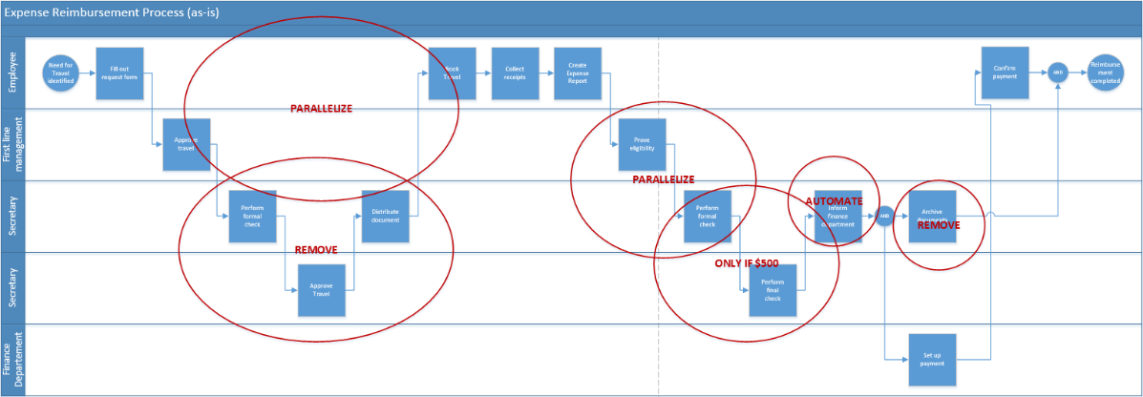***Areas of improvement (current process)*

**The reengineered process – parallel and database-driven**

To make the reengineering project successful, we have made sure to pick a process that has the required breadth. In this case, almost all departments are affected, as most of them have employees traveling regularly. If the process is substantially streamlined, it will result in greater efficiency for most Stark employees, but especially the bottleneck-functions such as the CFO and his/her secretary. It will directly increase employee satisfaction, and indirectly customer satisfaction as well. If management makes sure that the project also has the required depth (by investing a sufficient amount of money to implement the database, educate people on how to use it, etc.), commits fully to it and champions the design proposed by our team, the project will most likely be a success. For the process itself, we have decided to perform all the activities described in the last section:

* Remove the CFOs task of approving travel requests
* Allow the first line manager to deal with expense reports smaller than $500
* Parallelize booking and travel request approval
* Parallelize formal check and proof of eligibilty
* Remove the secretaries tasks of archiving all reports in paper and informing the finance department

This way we have not entirely eliminated waiting times, but reduced them to an amount that will substantially reduce the risk of employees unable to travel, to advance the payment of their business trips and to leave the company, while at the same time increase visibility and responsiveness of all parties involved.

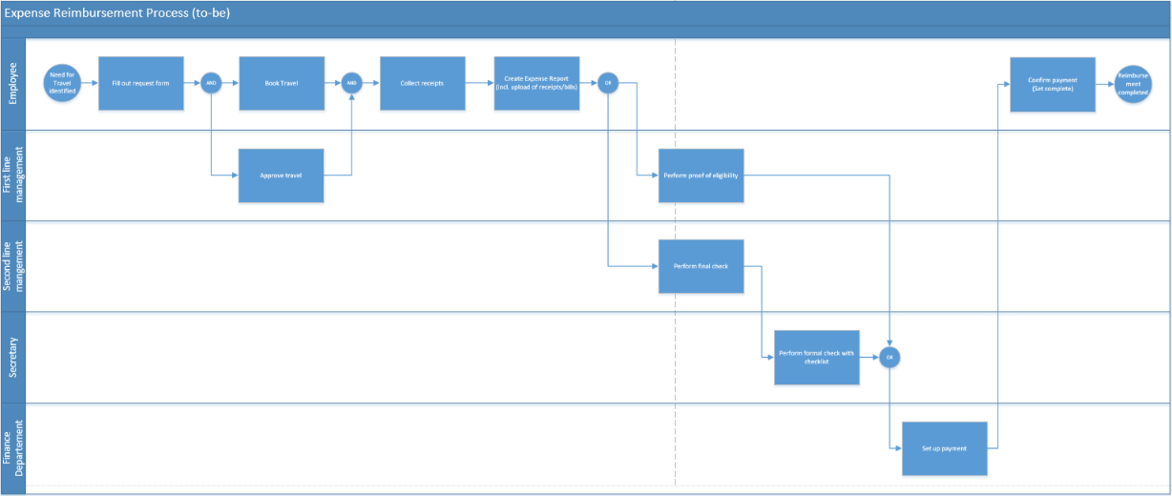  
*The reengineered process*